SYSTEM DIRECTOR POSITION OPEN

The Eastern Shore Public Library (ESPL) is seeking a dynamic, visionary leader, with proven management skills, for the position of System Director. Serving Accomack and Northampton Counties on the Eastern Shore of Virginia, ESPL is comprised of two branch and two affiliate libraries, as well as a modern archives facility, extensive local history collection, and flexible programming spaces.
Reporting directly to the Board of Trustees, the System Director is responsible for overseeing all aspects of System operations. ESPL employs nine full-time and 10 part-time positions, has a budget of $1.4 million, and a collection of over 440,000 books, ebooks, audiobooks, DVDs, and more. Halfway through FY 2024, ESPL saw a 47% increase in new library cards issued; a 1,013% increase in on-site program attendance; and 20% growth in circulation over the entirety of FY 2023.
The System Director works out of the new, state-of-the-art Regional Library and Heritage Center in Parksley opened in August, 2023.
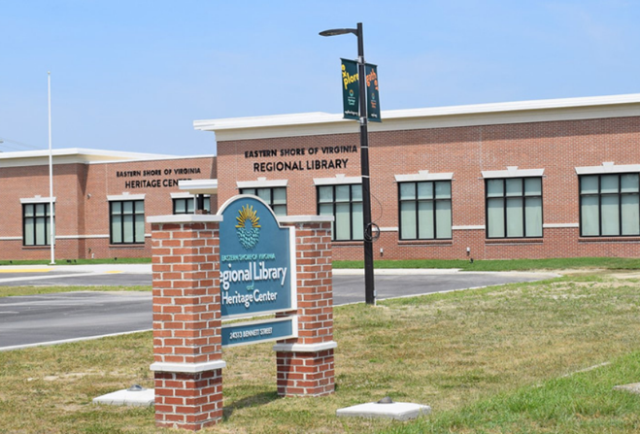

Position Requirements
We are seeking candidates with strong leadership, communication, and planning skills, as well as political and business acumen. Public speaking, grant writing, and technology implementation experience, along with familiarity with technological trends affecting the future of libraries, are desirable.
Qualifications
Master’s Degree in Library Science; at least three years of professional library experience, administrative management, and programming responsibility preferred. A complete job description is available at espl.org.
Candidates should apply by submitting a resume, cover letter, and three references to: directorsearch@espl.org. Please direct all inquiries to the same address.
Application Deadline: April 19, 2024, or open until filled.
Compensation: $80,000 - $90,000, plus benefits.
The Community
Situated between the Atlantic Ocean on the east and Chesapeake Bay on the west, the Eastern Shore of Virginia has the longest expanse of nature preserve remaining on the eastern seaboard. The Shore has a rich, 400-year-old recorded history and is home to many vibrant, supportive communities.

